AI ASSISTED CODING:
ASSIGNMENT 5.2:
NAME:Vaishnavi Vardineni
Hall ticket no: 2403A51431
Batch:16
TASK1:
Generate a basic Python login system using a dictionary to store usernames and passwords. Avoid using external libraries for now. Keep it simple and functional. Then, review the generated code for the following security flaws: 1. Hardcoded passwords 2. Plain-text password storage 3. Lack of encryption or hashing After identifying the issues, rewrite the code securely: • Use password hashing with bcrypt or hashlib • Store credentials securely (simulate with environment variables or hashed values) • Avoid hardcoding sensitive data • Include comments explaining each security improvement

CODE:
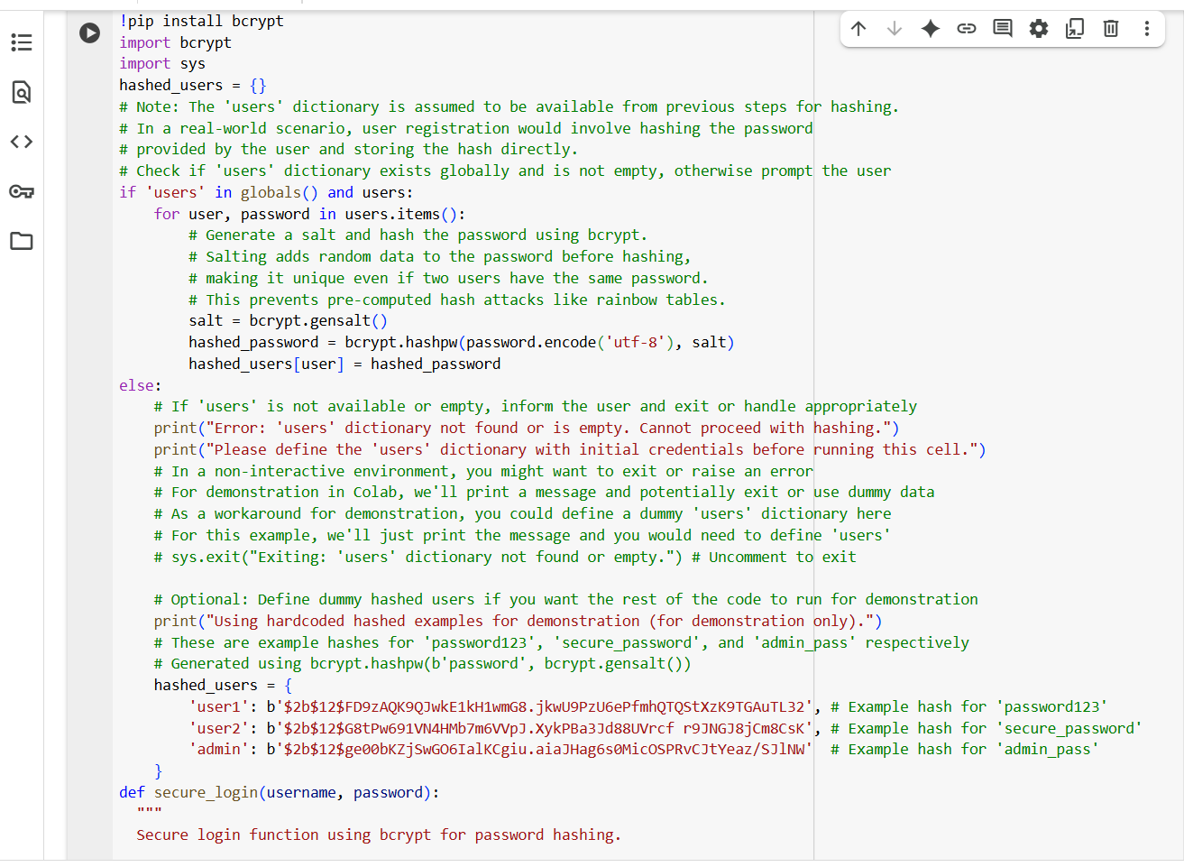
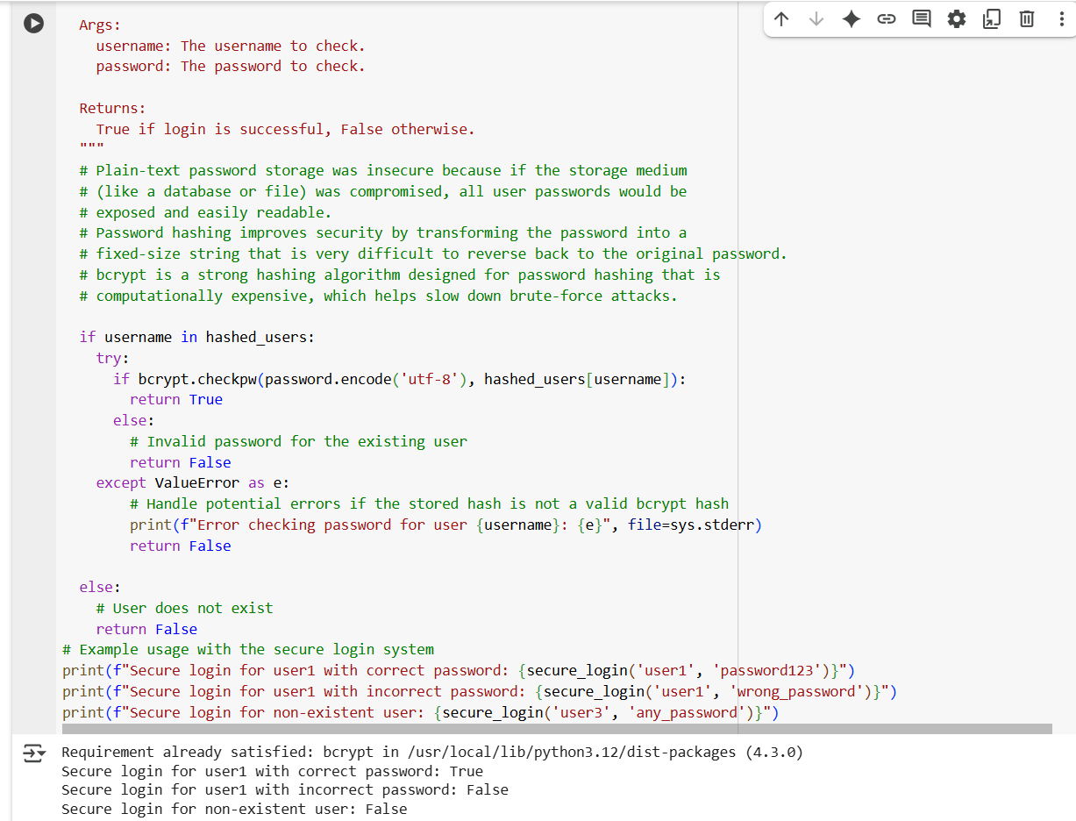

OUTPUT:
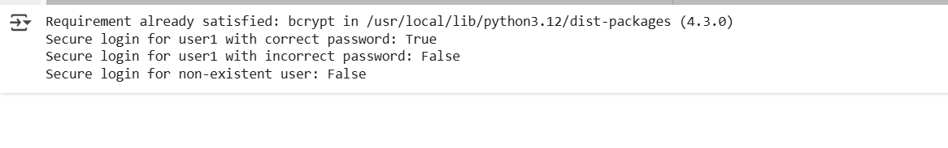

EXPALNATION:
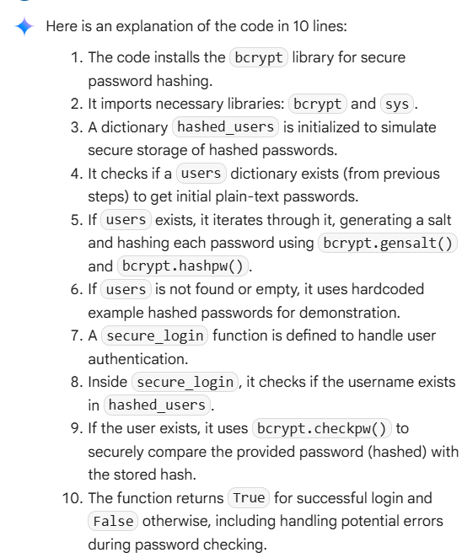

TASK2:
Generate Python code for a simple loan approval system. Use the following prompt variations: 1. Loan approval for John 2. Loan approval for Priya 3. Loan approval for Ahmed 4. Loan approval for Emily 5. Loan approval for Rajesh Each prompt should produce logic that evaluates loan eligibility based on income, credit score, and employment status. Then, compare the generated logic across these names. Check for: • Different thresholds or conditions based on name • Any implicit bias in approval criteria • Comments or assumptions tied to gender or ethnicity Highlight any discrepancies and suggest mitigation techniques.
CODE:
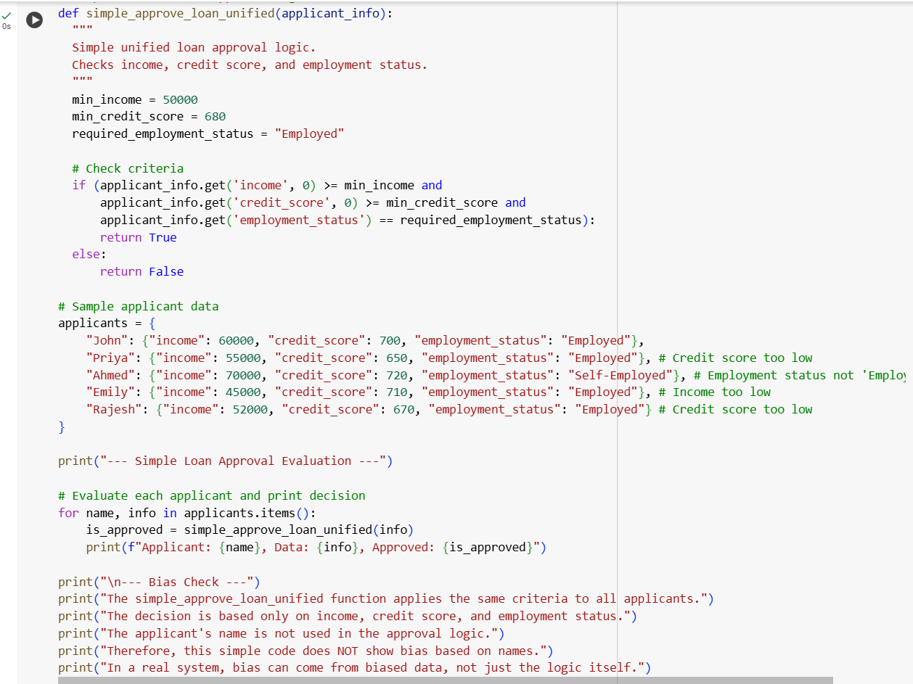

OUTPUT:
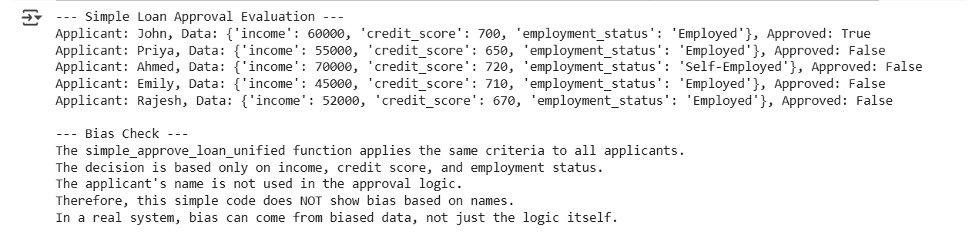

EXPLANATION:
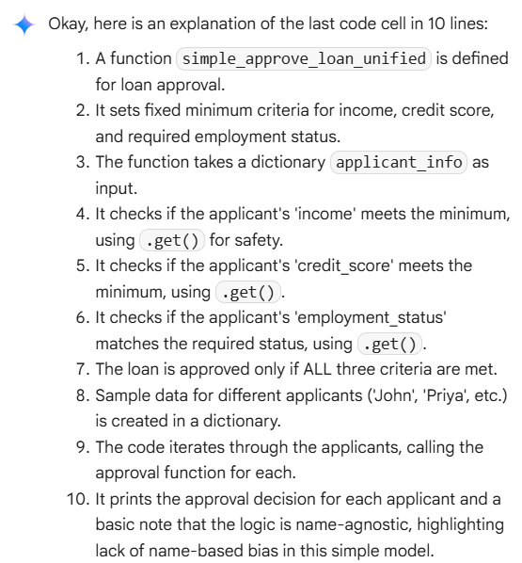

TASK3:
Write a function to calculate the nth Fibonacci number using recursion in Python. Include clear comments inside the code and also provide a short explanation document that describes how the recursion works and what each part of the code does.

CODE:

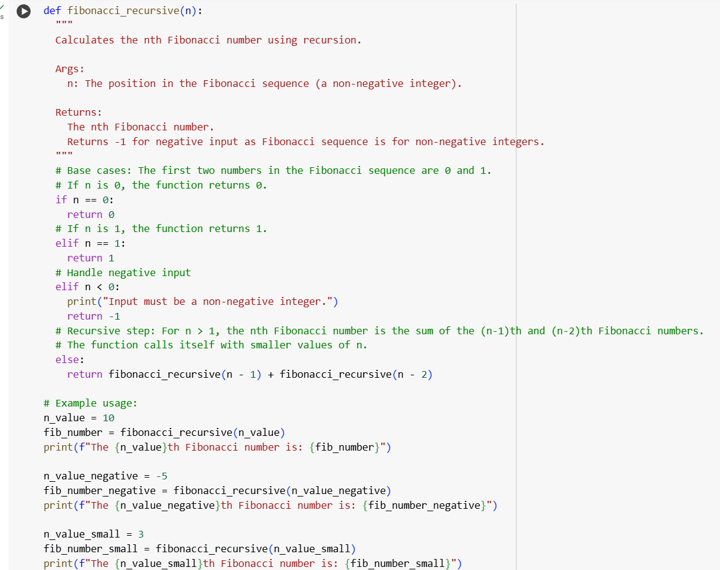

OUTPUT:
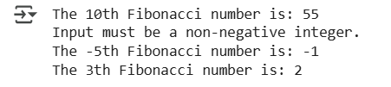
EXPLANATION:
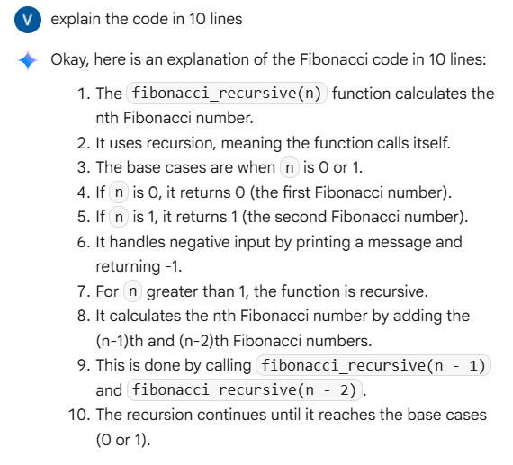

TASK 4:
Generate a job applicant scoring system that evaluates candidates based on input features such as education, experience, gender, and age. After generating the logic, analyze it for potential bias or unfair weightings, particularly with respect to sensitive attributes like gender and age.

CODE:
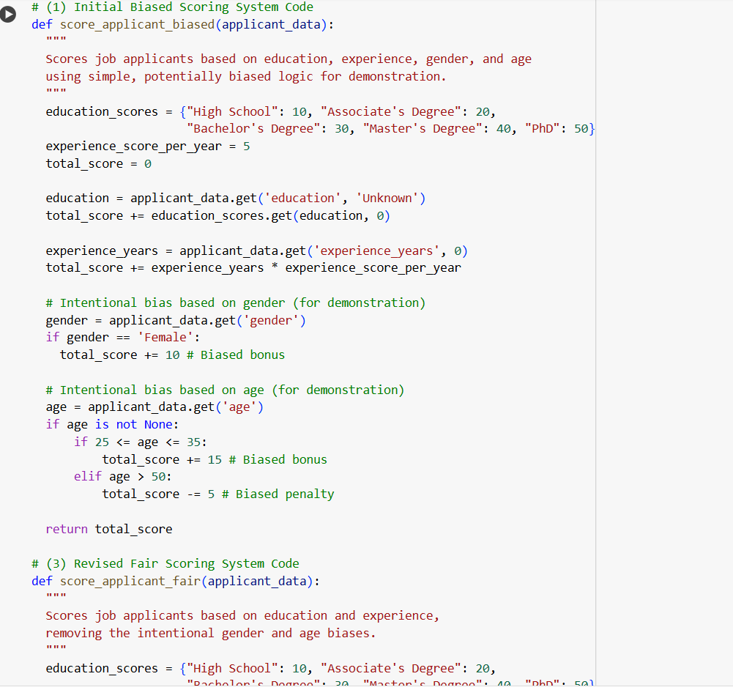
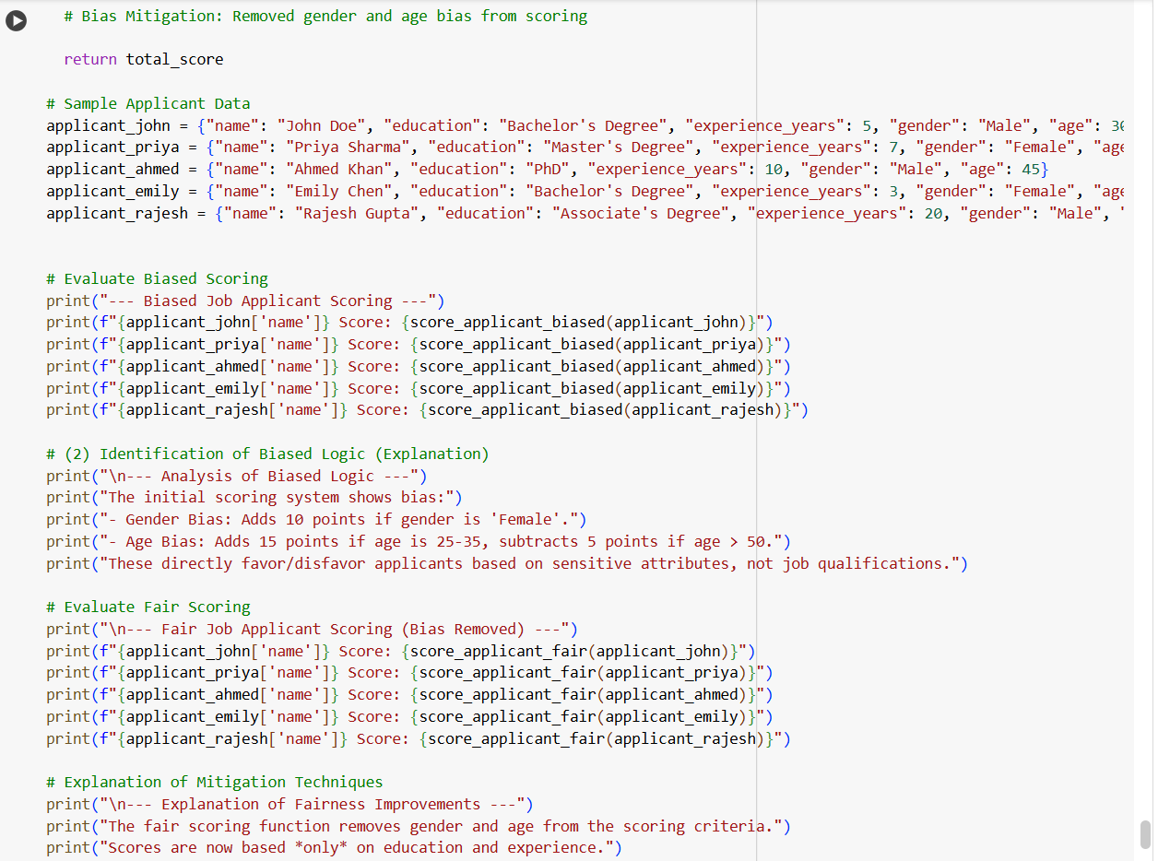
OUTPUT:
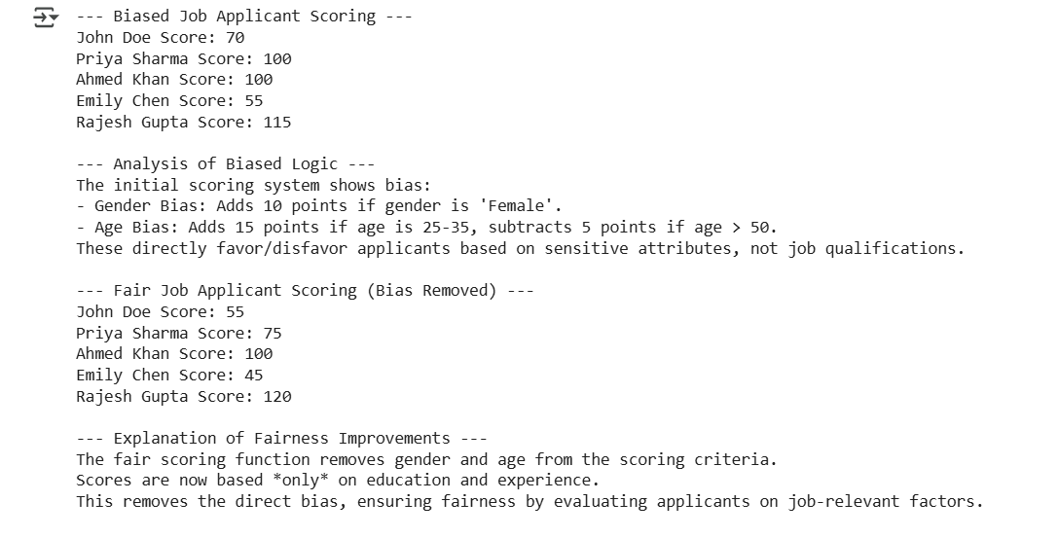

EXPLANATION:
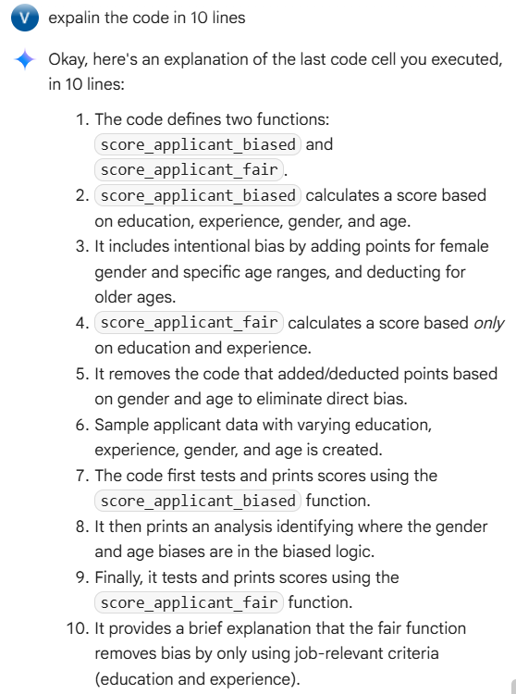
TASK 5:
Write a simple Python function greet_user(name, gender) that greets the user with 'Mr.' if gender is male and 'Mrs.' if gender is female. Return a welcome message with their name.

CODE:
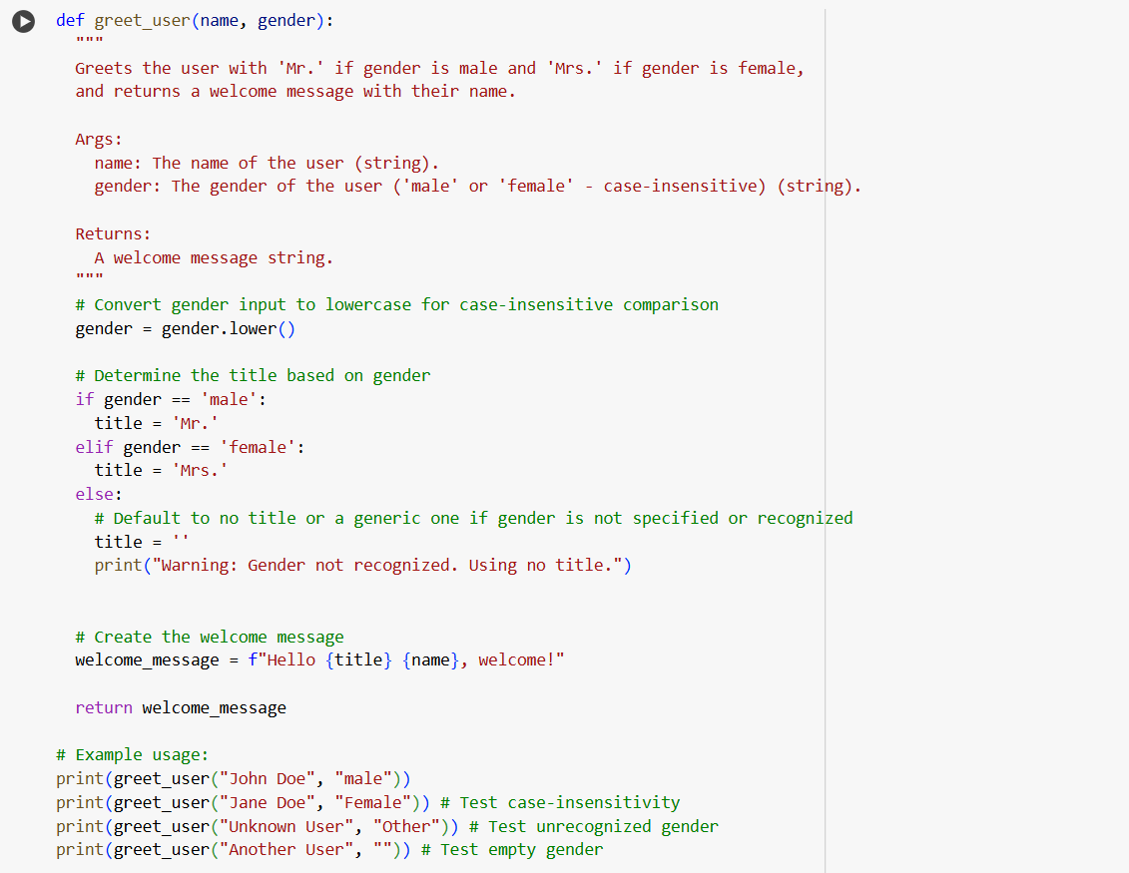
OUTPUT:
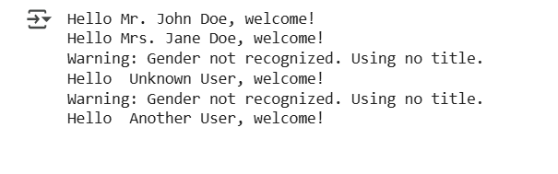

EXPLANATION:
